Muhammad Shayan 544810 BSCS-15-E

DSA LAB 2

Instructor: Urooj Akmal

Objectives: Learning and using array pointers and dereference operators.

Task 1

Part 1
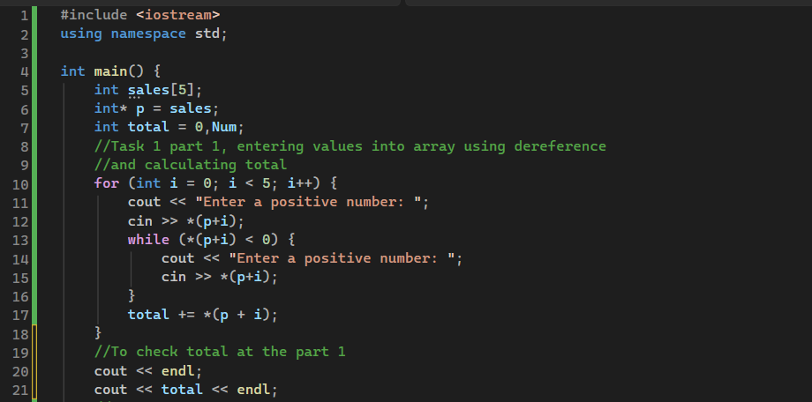
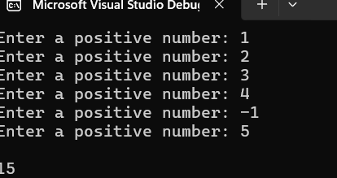

Part 2
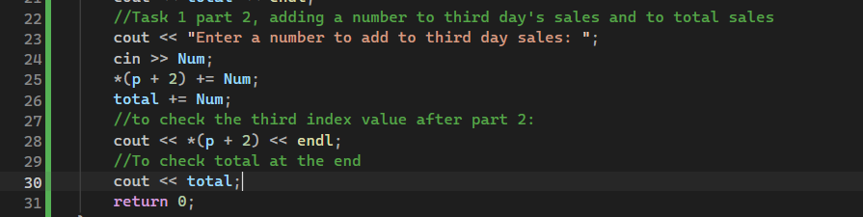
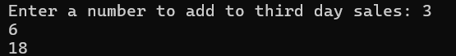

Part 3
- p : The pointer variable itself, this stores the address of the first index of the array sales
- &p : The address of the pointer variable, where the pointer variable is stored
- *p : The value at the first index of the array sales. Using dereference operator, we find
value at the address of the pointer. (Valid index)
- *(p+2) : The value at the third index of the array sales. (Valid index)
- *(p+5) : The value at the 6th index of the array sales. Invalid index as it tries to access
value outside of the defined size of array.

Task 2

Part 1
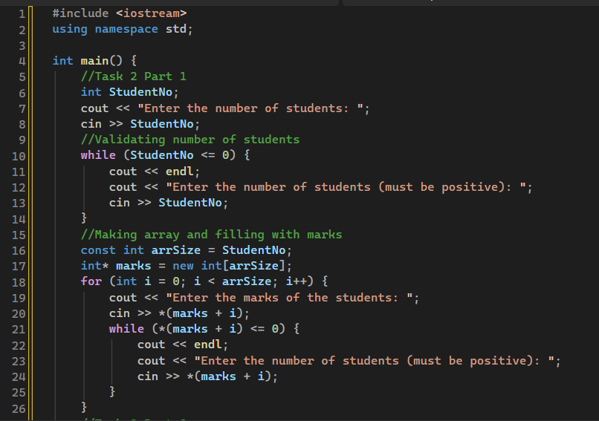

Part 2
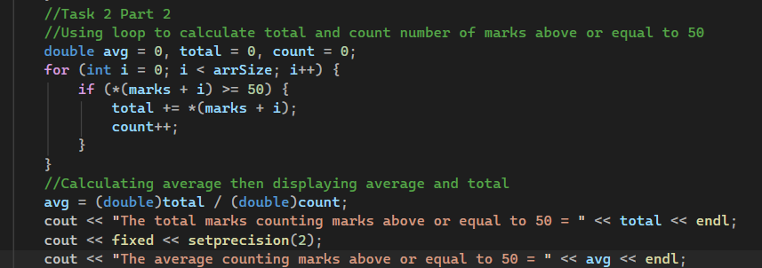

Part 1,2 Result
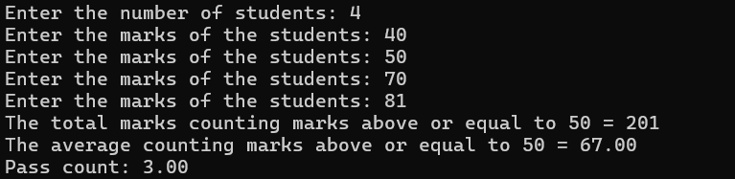

Part 3
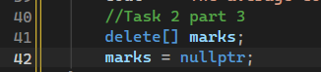
The pointer variable itself is a variable stored on the stack that contains an address of the heap, pointing to the start of the array, the allocated elements are stored in the heap and are storing the values themselves stored in the array.

Part 4

We have to use new marks int[n] as c++ does not support the declaration with a variable where the variable is placed in the index size, eg: int marks[n];. The int marks[n] is run at compile time, so the value of n must be known at compile time, in this case when we are taking input, that value is unknown so the array cannot be created with an undefined value at compile time.

Task 3

Part 1,2
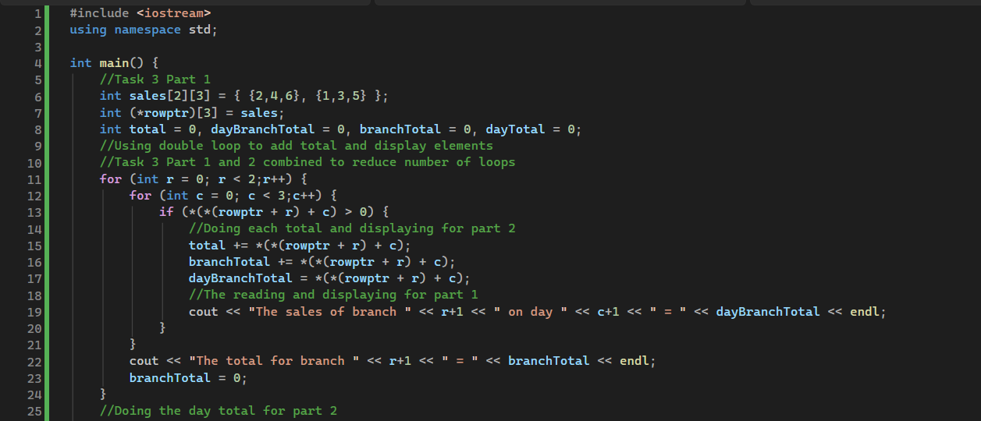
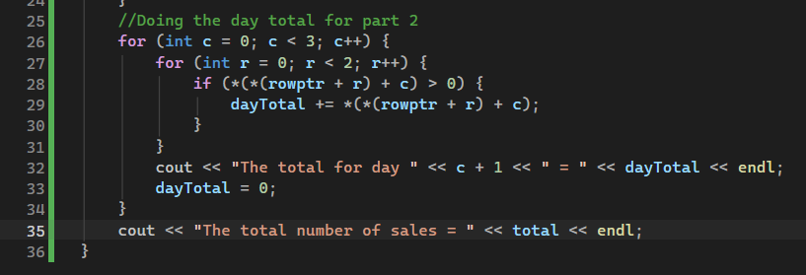
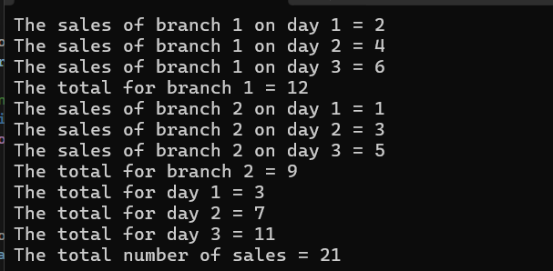

Part 3
Rowptr + 1 simply is the address pointing the second value in our array.
An int* pointing to one integer would simply jump by the number of bytes in the integer added to that pointer,because it does not know that it has to go only 1 index forward as is the case when using a pointer pointing to an array. **p should not be used because we are using a standard array and not a pointer to an array of pointers, **p will only be useful in that case.

Task 4

Part 1,2
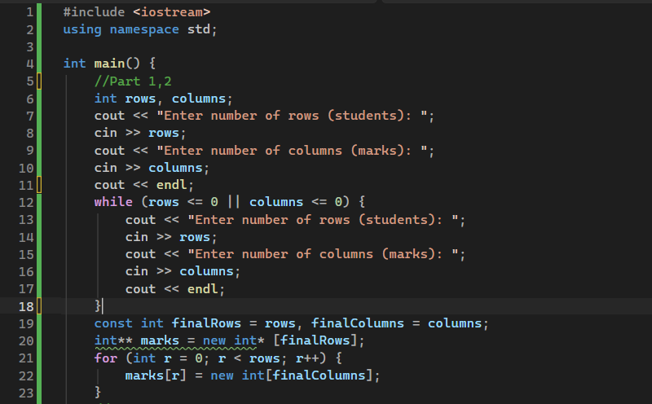

Part 3,4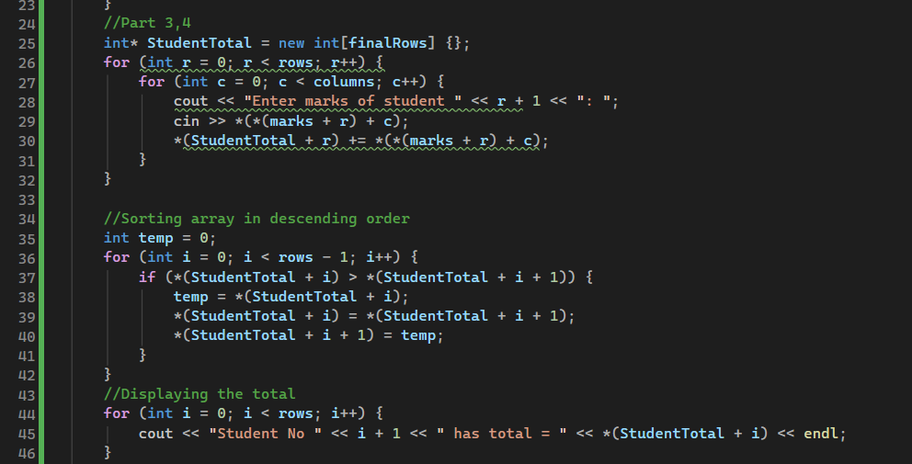

Part 1–4 Result
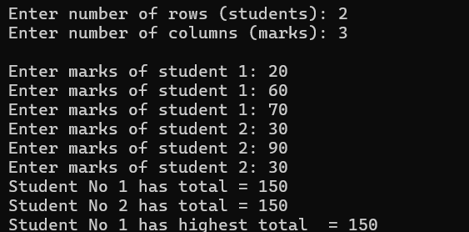

Part 5
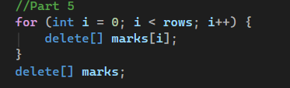
If only delete[] marks would be executed, the memory leak would occur with the arrays which each row was pointing to, and this would waste a lot of memory and will not be able to deleted as the address is lost.

Part 6
The pointer variable would point to the array of pointers, with a double pointer variable.
**p = new int*[2]
And we would use a for loop that runs twice, and adds a pointer to an array of three indices to each index of the array **p is pointing towards.
The rows would hold the students pointers, and the marks would be in the arrays those pointers are pointing to, in this case, that array will be of size 3.

Task 5
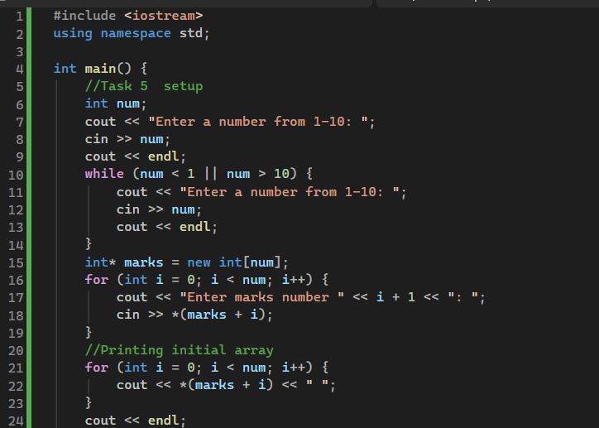

Part 1
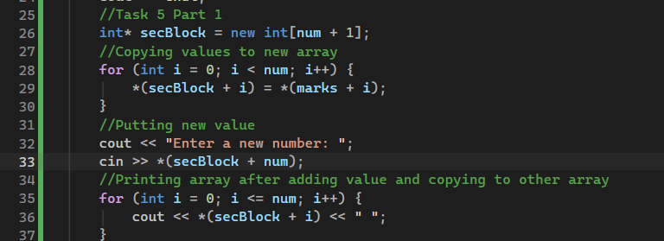

Part 2
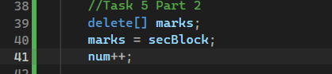

Part 3
Changing the number (num in my code) does not change the size of the array because it is used to declare an array of that size during runtime, changing the value of the num after the declaration of the array does not change anything about the array as it has already been declared and does not affect the size of array that has already been created with a constant size.

Final Result
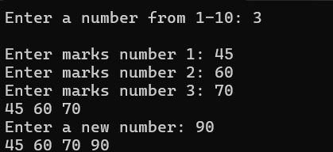

Task 6

Part 1
- The line: cin >> values[i]; is used when the for loop runs from 0 to <= n, which will cause an index out of bounds error when the program runs, as this will go to the for example 7th index of a size 6 array
- The line delete values; is used to release the pointer, but it is incorrect as it should be delete[] values, to release the entire array. This statement will cause a memory leak as the statement will only delete the pointer and release the first index of the array.
- The statement: cout << values[0]; is used after deletion of the pointer, so it will be causing an error of some kind as we are trying to output a value from an address of a pointer, when the address has been released. If the address is taken up by some other program, the output will be that value, and it can also be empty which can cause an error

Part 2
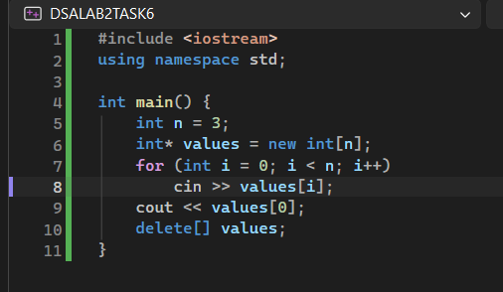

Part 3
The errors mentioned in this questions are answered in the problems identified in part 1 with the order corresponding to the numbering of errors in Part 1.
As for the explanation to why a program can appear to run successfully with memory accesses being valid, the program can complete execution without crashing as invalid memory access is not such an error that immediately causes a crash, it can cause unpredictable and undefined behaviour, such as outputting random values or outputting random addresses, but accessing an incorrect memory location does not crash the program, so it can appear to complete execution without causing an error.

